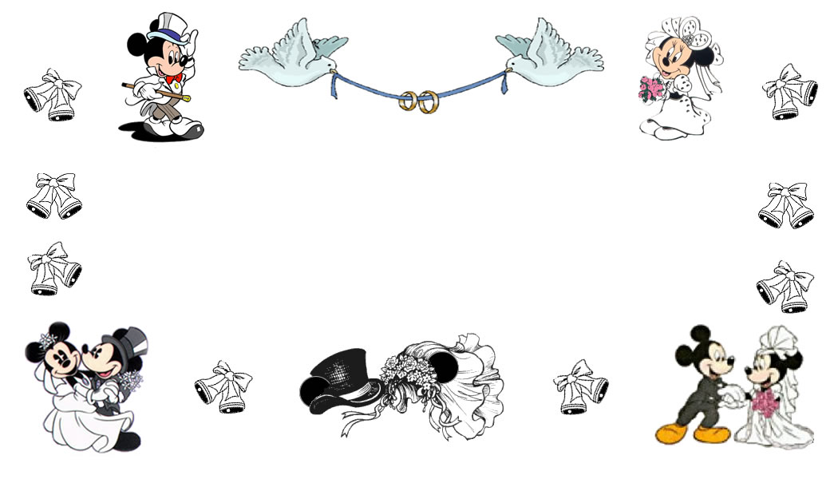  Name:  Address:  Phone: | Name:  Address:  Phone:
Name:  Address:  Phone: | Name:  Address:  Phone:
Name:  Address:  Phone: | Name:  Address:  Phone:
Name:  Address:  Phone: | Name:  Address:  Phone:
Name:  Address:  Phone: | Name:  Address:  Phone:

