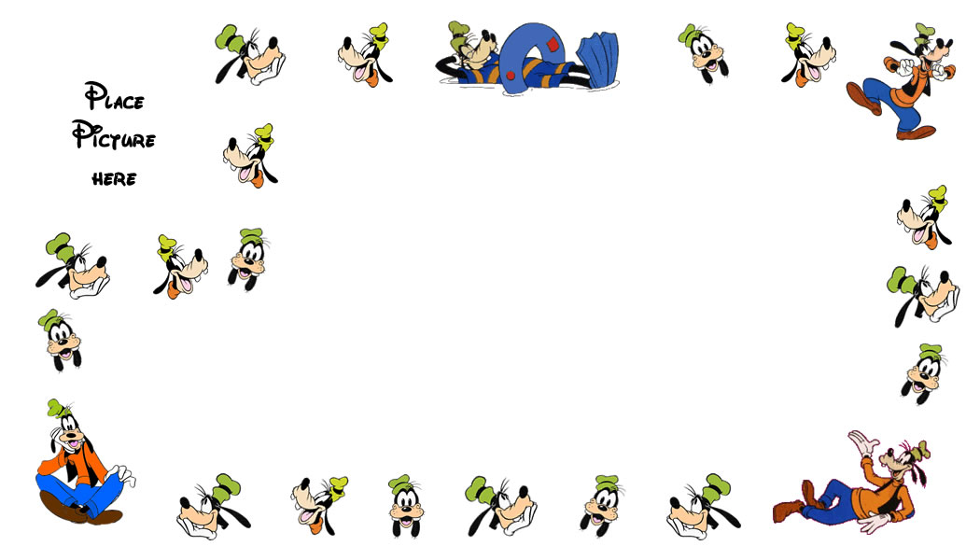  I am traveling with:  We are staying at:  Phone:  My name is:  I am ______ years old  I am _________ tall  I weight _______ lbs | I am traveling with:  We are staying at:  Phone:  My name is:  I am ______ years old  I am _________ tall  I weight _______ lbs
I am traveling with:  We are staying at:  Phone:  My name is:  I am ______ years old  I am _________ tall  I weight _______ lbs | I am traveling with:  We are staying at:  Phone:  My name is:  I am ______ years old  I am _________ tall  I weight _______ lbs
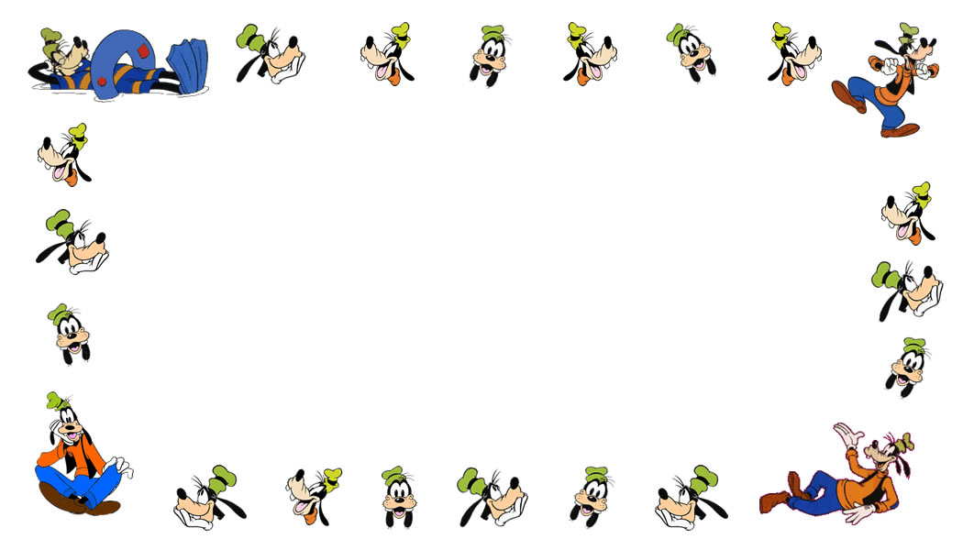  Name:  Address:  Phone: | Name:  Address:  Phone:
Name:  Address:  Phone: | Name:  Address:  Phone:
Name: | Name:

