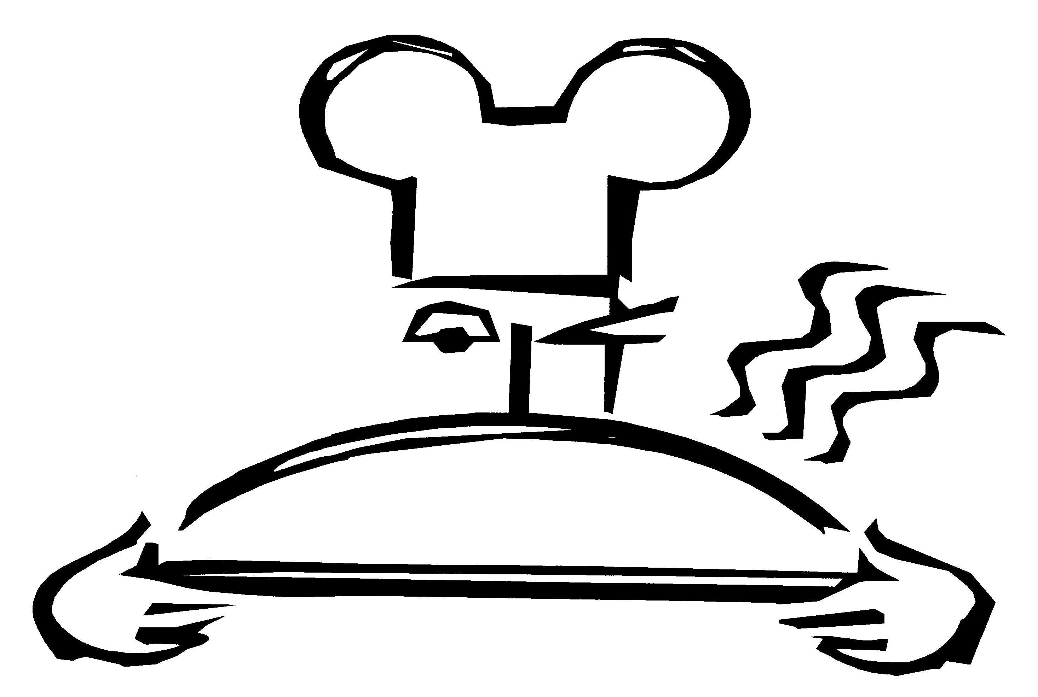

Walt Disney World®
Food & Beverage

MAGIC KINGDOM® Park
No Gluten Added Products

Below are products that we believe are gluten-free based on our review of the manufacturer’s ingredient label. **Always ask to speak to a chef or manager, vendors and ingredients change and we are always striving to improve. Ingredient labels are available upon request.

Cosmic Ray’s Starlight Cafe | Aloha Isle
Rotisserie Chicken | Pineapple juice, Dole
Hamburger with an EnerG Foods Hamburger Bun | Dole Whip Vanilla
Hot Dog with an EnerG Foods Hot Dog Bun | Dole Whip Chocolate
Fries done in an oven | Dole Whip Pineapple

Grilled chicken on an EnerG Foods Bun
 | Sunshine Tree
Turkey Wagon/Lunching Pad | Orange Concentrate
Smoked Turkey Drumstick-Crofton & Sons | Vanilla flavored ice cream
 | Chocolate flavored ice cream

El Pirata Y El Perico (Seasonal)
Salsa | Pinocchio Village Haus
Scuttle’s Landing | Gluten-free Pizza & Macaroni & Cheese (Amy’s)
Assorted carbonated frozen beverages | Fries Baked in Oven
Toon Town Farmer’s Market/Liberty Square Market | Main Street Bakery
Fresh fruit and fruit cups | Cut Fruit
Potato Cart – Liberty Square  Strawberry/Mixed Fruit Yogurt | *Delicious Fudgie Brownie/Chocolate Chip Cookie – French Meadow
Outdoor food carts | Pecos Bills Tall Tale Inn & Cafe
Itzakadoozie Cool Creations | Hamburger with EnerG Foods Bun
Strawberry Fruit Bar – Edy’s | G/F Chocolate Chip Cookie
Mickey’s Premium Ice Cream Bar
Frozen Banana | Auntie Gravities
Frozen Lemonade/Strawberry Lemonade – Nestle | Soft serve without the cone
Popcorn | Smoothies – Strawberry, Banana
 | Cappuccino, Mango-Passion,
Casey’s Corner | Orange-Pineapple, Pina-Colada
Hot Dog on EnerG roll | Carmel Topping
Columbia Harbor House | Enchanted Grove
Allergy Free Chicken Tenders-Allergy Free Foods Co.  Fries baked in oven  Amy’s Macaroni & Cheese | Soft Serve Vanilla without cone Strawberry Swirl  Lemonade Slush  Raspberry Lemonade Slush

Plaza Ice Cream Parlor
Gluten-free ice cream
Dairy-free ice cream

Epcot®
No Gluten Added Products
Table Service Restaurants

Below are products that we believe are gluten-free based on our review of the manufacturer’s ingredient label. **Always ask to speak to a chef or manager, vendors and ingredients change and we are always striving to improve. Ingredient labels are available upon request.

Princess Storybook – Norway | Chefs de France and Bistro de Paris
Van’s Waffles | Salad
Turkey Sausage | Grilled Meat or Fish
Pancake Mix  Dinner Rolls | Vegetables  Crème Brulee
Hamburger Buns | EnerG rolls
Hot Dog Buns  Hot Dog | Marrakesh (Morocco)
Itzakadoozie Popsicles  Chocolate Chip Cookie Mix | Jasmina Salad  Shish Kebab – Chicken or Beef
Rice Macaroni and Cheese (Amy’s)  Pizza (Amy’s) | Tagine of Fish  Fresh Fruit in Orange Juice
Rice spaghetti
Quinoa – Wheat-free Pasta Elbows
 | Le Cellier – Canada
 | Brownies
 | Gluten free tapioca rolls
San Angel Inn | Edy’s Vanilla Ice Cream
Grilled Chicken Breast*  Chicken Quesadilla* | Maple Crème Brule  Seasonal Sorbet
Beef Tacos*  Carne Asada Tampiquena (Beef Tenderloin)*  Grilled Mahi-Mahi* | Apple Slices  Mixed Fruit  Carrots and Celery
Served with Mexican Rice  Ensalada Mexicana (Salad) | Beans and Carrots  Hamburger
Brownie  Fruit Sorbet and Fresh Fruit | French fries  Mashed Potatoes
 | Roasted Potatoes
Biergarten – Germany | Mushroom Risotto
Gluten-free Dinner Rolls | Kansas City Steak
Brownies | NY Strip Steak
Rice Dream Ice Cream/Tofutti Ice Cream | Kid Sirloin
Rice Milk, Soy Milk | Filet
Fruit Salad, Potatoes, Wurst Salad | Veal
Amy’s Macaroni & Cheese (by request) | Prime Rib
Allergen Free Chicken Tenders (by request) | Kid Chicken
Chicken, Pork Roast, Red Cabbage, | Airline Chicken
Sauerkraut, Sausages, Regensburger, Rote Grutze, | Asparagus
Cabbage Salad, Beet Salad, Veal Loaf | Scallop
 | Salmon no sauces
 | Mussels

Epcot®
No Gluten Added Products
Table Service Restaurants

Below are products that we believe are gluten-free based on our review of the manufacturer’s ingredient label. **Always ask to speak to a chef or manager, vendors and ingredients change and we are always striving to improve. Ingredient labels are available upon request.

Garden Grill – The Land | Coral Reef – Living Seas
Rice Macaroni and Cheese | Mixed Green Salad
Dinner Rolls | Caesar Salad
Rice Pasta | Butter Nut Squash Soup with Jalapeno whipped cream
Brownie | EnerG dinner rolls
Pizza  Ancient Harvest Wheat-Free Elbow Pasta | Sauteed Shrimp over Saffron Risotto with roasted zucchini and tomatoes
Chocolate Chip Cookies  Rotisserie Chicken with Advance Notice  Roasted Turkey Breast | Seared Rainbow Trout with warm salad of white bean, arugula, tomatoes, crispy bacon, aged Balsamic vinegar and brown butter
French Fries  Flank Steak | Grilled Mahi Mahi with ragu of rock shrimp served on Jasmine Rice topped with hearts of palm
Roasted Potatoes  Garden Fresh Vegetables (seasonal) | Seared Tilapia served on mixed greens with roasted vegetables and tomato vinaigrette
Itzakadoozie Popsicle | Braised NY Strip served with roasted new potatoes
 | Chocolate Wave Cake
Rose & Crown | Butterscotch Crème Brulee
Rice Pasta
Dinner Rolls | Tutto Italia
Chicken | Rice Pasta
Sirloin Steak | Dinner Rolls
Pork Dinner
Fish & Chips

Epcot®
No Gluten Added Products
Quick Service Restaurants

Below are products that we believe are gluten-free based on our review of the manufacturer’s ingredient label. **Always ask to speak to a chef or manager, vendors and ingredients change and we are always striving to improve. Ingredient labels are available upon request.

Liberty Inn
Hamburger with EnerG Foods Hamburger Bun
Hot dog with EnerG Foods Hot Dog Bun
Macaroni and Cheese (Amy’s)
Baked Fries with Advance Notice
Chocolate Chip Cookies (GLP)
Brownie (GLP)
Turkey Cart in American Adventure
Smoked Turkey Drumstick – Croften and Sons
Outdoor Food Carts
Itzakadoozie Cook Creations | Popcorn
Mickey’s Premium Ice Cream Bar | Nestle frozen Lemonade/Strawberry Lemonade
Strawberry Fruit Bars – Edy’s | Nestle Pineapple Bar.
Frozen Banana | Fresh Fruit
Hot Dog Cart
Hot Dog without Bun
Sunshine Seasons (Located in the Land Pavilion)
Brownie | Rotisserie Chicken
Rice Pasta with Advance Notice | Pork Chip
Dinner Roll with Advance Notice | Grilled Salmon
Chocolate Chip Cookies (Pamela’s) | Kid Drumstick
Pecan Shortbread Cookies (Pamela’s) | Yellow Rice
Salad with Apple Balsamic Vinaigrette | Jasmine rice (white rice)
Steamed Broccoli | Glazed Carrots
Vegan Black Bean Soup | Caesar Salad w/o Croutons
Roasted beet and Goat Cheese Salad w/o Lavash Crackers | Itzakadoozie popsicle
Grapes, Carrot Stix, Jell-O, Applesauce | Chocolate Pudding (Kid’s pick dessert options)
Turkey Cart – Test Track
Turkey Leg
Electric Umbrella
Hamburger EnerG Foods Hamburger Bun
Allergey Free Foods Chicken Tenderloins
Gluten-Free Macaroni & Cheese (Amy’s)
Gluten-free gelatin
Baked Fries

Disney’s Animal Kingdom® Park
No Gluten Added Products

Below are products that we believe are gluten-free based on our review of the manufacturer’s ingredient label. **Always ask to speak to a chef or manager, vendors and ingredients change and we are always striving to improve. Ingredient labels are available upon request.

AFRICA

Harambe Fruit Cart
Fresh fruit and Fruit Cups
Kusafiri Bakery
Gluten-Free Brownie
Enjoy Life Cookies
DISCOVERY ISLAND
Flame Tree BBQ | Turkey Wagon
BBQ Ribs and BBQ Chicken | Smoked Turkey Drumstick – Crofton & Sons
BBQ Chicken Salad w/o Tortilla
Fresh Fruit Plate | Pizzafari
Frozen Lemonade Nestle | Amy’s Rice Crust Cheese Pizza
BBQ Pork on a Ener-G Bun | Gluten-free Brownie
Hot Dogs on Ener-G Bun | Enjoy Life Cookies
Gluten-free Brownie

Enjoy Life Cookies
DINOLAND
Restorantosaurus | Dino Diner
Hamburger w/EnerG Foods Hamburger Bun | Assorted Carbonated Frozen Beverages

Hot dog w/Ener-G Foods Hot Dog Bun
Amy’s Rice Mac & Cheese | Dino Bites
Fries | Tofutti and Rice Rice
Enjoy Life Cookies | Ice Cream
Allergy Free Chicken Tenders- Allergy Free Foods Co. | TriloBites
Gluten Free Brownie | Smoked Turkey Drumstick – Crofton & Sons
 | Carbonated Frozen Lemonade

OUTDOOR FOOD CARTS
Frozen Strawberry Fruit Bar – Edy’s. | Frozen Banana
Mickey’s Premium Ice Cream Bar | Popcorn
Frozen Pineapple Juice Bar – Nestle | Nestle Frozen Lemonade/Strawberry Lemonade

Disney's Hollywood Studios™
No Gluten Added Products

Below are products that we believe are gluten-free based on our review of the manufacturer’s ingredient label. **Always ask to speak to a chef or manager, vendors and ingredients change and we are always striving to improve. Ingredient labels are available upon request.

ABC Commissary | Teen’s and Tween’s
All-Beef Hamburger with the Ener-G Foods Bun | Soft Serve Ice Cream without the cone
Chicken Bleu Sandwich with the Ener-G Foods Bun | Smoothie’s- Mango-Passion, Orange-
French Fries in a designated fryer | Pineapple, Strawberry, Banana, Cappuccino
Enjoy Life Chocolate Chip Cookie | Gluten-free Brownie
Kid’s Meal Turkey Sandwich | Enjoy Life Chocolate Chip Cookie
Gluten-Free Brownie
Backlot Express | Min & Bill’s Dockside Diner
All-Beef Hamburger with the Ener-G Foods Bun | Chocolate and Vanilla Milk Shakes
All-Beef Hot Dog with Ener-G Foods Bun
Black Bean Salad | Outdoor Foods
Southwest Salad | Frozen Banana
Enjoy Life Chocolate Chip Cookie | Itzakadoozie
Gluten-free Brownie | Mickey’s Premium Ice Cream Bar
 | Strawberry Fruit Bar – Edy’s
Dinosaur Gertie’s | Popcorn
Chocolate and Vanilla Soft Serve Ice Cream without the cone
Toy Story Pizza Planet | Studio Catering Co. Flatbread Grill
Amy’s Brand Gluten Free Pizza | Grilled Chicken Breast Quarter with Black Beans
Toy Story Chicken Salad | and White Rice
Caprese Salad | Greek Salad
Side Salad | All-Beef Hot Dog without the Chili
EnerG Pizza Crust | Enjoy Life Chocolate Chip Cookies
Soy Cheese | Gluten Free Brownie

Enjoy Life Chocolate Chip Cookies

Gluten Free Brownie

Sunset Market Ranch
Anaheim Produce: | Rosie’s:
Whole Fruits | Hamburger without the Bun
Seasonal Berries | Potato Salad

Carrots
Grapes | Fair Fax Faire:
Mixed Fruit | All-Beef Hot Dog without Chili
 | Pork Salad

Toluca Legs:

Smoked Turkey Leg

